# 

# **Image Caption Generator**

## **Introduction**

Image captioning is a complex task that involves generating descriptive sentences for images. It is challenging because it necessitates the system to comprehend the images' content and produce an accurate and informative caption.

This project aims to develop an image caption generator using a deep learning model. The model is trained on a dataset consisting of image caption pairs. By extracting features from images, the model can generate appropriate captions that describe the images content.

The findings of this project can be utilized to enhance the design and development of forthcoming image captioning systems.

## **Literature Survey**

The issue of image captioning has been thoroughly examined by experts in the fields of computer vision and natural language processing. Various methods have been proposed to tackle this problem. However. They all strive for a common objective: producing a precise and insightful description in natural language that corresponds to an image. Some of the most common approaches to image captioning include:

* The bag of words: This approach represents images as a collection of visual features, or words. These words are extracted from the image and stored in a bag. To generate a caption word are selected from the bag based on their likelihood of occurring together.
* Hidden Markov models: It takes a different approach by modeling the relationship between words in a caption as a hidden Markov model. This model is trained on a dataset of image caption pairs and can be used to generate captions for new images by following the patterns learned during training.
* Recurrent neural networks: It models the caption generation as a sequence of decisions. These models are trained on image caption pairs and generate captions for new images by making decisions about which words to use at each step in the sequence.

The model employed in this project is a combination of a convolutional neural network (CNN) and a recurrent neural network (RNN) decoder. The CNN plays the role of extracting features from images. While the RNN is responsible for generating captions based on these features. To train the model we adopt a supervised learning approach using a dataset composed of image caption pairs. Each image is associated with its respective caption enabling the model to learn how to generate accurate captions for new images that resemble those in the training dataset.

## **Theoretical Analysis**

### Block diagram

The block diagram of the image captioning system is shown below.

[Image] --> CNN --> RNN --> [Caption]

The CNN is utilized to extract features from the image. While the RNN is employed to generate a caption based on the features obtained by the CNN.

The CNN, a deep learning model. Undergoes training using a dataset of images to identify various objects and scenes present in the images. As well as comprehend the relationships between them.

Similarly, the RNN also undergoes deep learning training using a dataset of text to generate text by predicting subsequent words in a sequence while considering the context of previous words.

Combining both the CNN and RNN in an image captioning system enables the generation of captions for images, where the CNN extracts feature from the image and subsequently utilizes these features for generating captions through the RNN.

### Hardware / Software designing

To effectively run the image captioning system, it is necessary to have a computer equipped with a GPU and sufficient memory to accommodate both the model and the training data. In addition. The software prerequisites include Python and the TensorFlow library.

## **Experimental Investigations**

The image captioning system was assessed using a dataset consisting of 8,091 images.

The image captioning system has been able to produce accurate and informative captions during evaluation. The system is able to generate captions for a wide variety of images, and the captions are generally consistent with the content of the images.

## **Flowchart**

The flowchart of the image captioning system is shown below.

Start

Read image

Extract features from image using CNN

Generate caption using RNN

Write caption to file

End

The flowchart shows the steps that the image captioning system takes to generate a caption for an image.

* Read image: To begin it is important to read the image either from a file or a URL. This step allows us to obtain the necessary data for further analysis.
* Extract features from image using CNN: Once the image has been read. The next crucial step involves extracting features from it using a convolutional neural network (CNN). By utilizing this advanced technology. We are able to train the CNN to identify various objects and scenes present within the image. Additionally. The CNN is capable of understanding and recognizing the relationships that exist between these objects and scenes.
* Generate caption using RNN: Subsequently a caption needs to be generated using a recurrent neural network (RNN). Through this process. The RNN learns how to predict the next word in a sequence of text. Enabling it to generate an appropriate caption. Moreover, contextual information from previous words in the sequence is taken into consideration by the RNN.
* Write caption to file: After generating a caption that accurately reflects the content of the image. It can be written to a file for future reference. Additionally, if desired this caption can also be displayed on screen or utilized in other applications as needed.

## **Result**

The final findings of the project are as follows:

* The image captioning system possesses the capability to generate captions for a diverse range of images.
* The system is highly proficient in generating captions that are not only precise but also provide valuable information.
* The system can be used to generate captions for a variety of applications, such as:
  + Search engines: The system has the capability to generate captions for images that are utilized in search results thereby assisting users in comprehending the content of the images more effectively.
  + Social media: The incorporation of this particular system empowers users by generating customized captions for images shared on multiple social media platforms. Such an approach not only enhances their understanding of image content. But also fosters deeper engagement and interaction with it. Leading to more meaningful experiences overall.
  + E-commerce websites: The system has the capability to generate captions for product images that are being sold on e-commerce websites. By providing users with this feature, it aims to enhance their comprehension of the products and enable them to make well informed decisions when purchasing.

## **Advantages & Disadvantages**

The advantages of the proposed solution include:

* The current system has the capability to generate captions for a diverse range of images.
* The captions are not only precise but also provide valuable information.
* This system is versatile and can be utilized in various applications to generate captions.

The disadvantages of the proposed solution include:

* The system can be slow to generate captions for large images.
* The system can sometimes generate incorrect or inaccurate captions.
* The system requires a large amount of training data to generate high-quality captions.

## **Applications**

The proposed solution can be applied to a variety of applications, such as:

* Search engines: Utilizing this system allows for the generation of captions accompanying images showcased in search results. Consequently, users can enhance their understanding of the visuals' content.
* Social media: The system is capable of generating captions for images that are shared on social media, which can assist users in comprehending the image’s content and establishing more meaningful interaction with them.
* E-commerce websites: The utilization of this system enables the generation of captions for product images available on e-commerce websites. This feature serves to enhance user comprehension of the products and facilitates well informed purchasing choices.
* Virtual assistants: The system provides a useful feature by generating captions for images shown on virtual assistants. This allows users to gain a clearer understanding of the image content and engage in more natural interactions with the virtual assistant.
* Self-driving cars: The system has the ability to generate captions for images taken by self-driving cars. This assists the cars in gaining a better understanding of their surroundings and enables them to make more informed and secure driving choices.

## **Conclusion**

The proposed solution is a practical and efficient method for generating captions for images. The system has the ability to generate accurate and informative captions for a diverse range of images. The system can be used to generate captions for a variety of applications, and it has the potential to improve the way that we interact with images.

## **Future Scope**

There are several potential future avenues for this project. They are:

* One possibility is to enhance the accuracy and informativeness of the captions generated. This could involve utilizing a more extensive and diverse collection of image caption pairs or employing more advanced machine learning techniques.
* Another direction to explore is making the system faster and more scalable. This could be achieved by implementing more efficient machine learning algorithms or harnessing cloud computing resources.
* Expanding the system to generate captions in other languages is also worth considering. Training the system with a dataset containing image caption pairs in multiple languages would pave the way for this development.
* Furthermore. Making the system more interactive is another promising prospect. Allowing users to provide feedback on the generated captions or enabling them to have control over the caption generation process would greatly enhance user experience.
* Additionally, there is potential in utilizing this system to generate captions for different types of media including videos and audio recordings. Incorporating techniques from computer vision and natural language processing would facilitate feature extraction from such media sources.

Ultimately the future scope of this project knows no bounds, contingent upon our imagination and data availability. With continual advancements in machine learning techniques alongside an ever-expanding pool of image caption data. We can anticipate witnessing even more impressive results from image captioning systems in forthcoming years.

## **Appendix**

### Source code

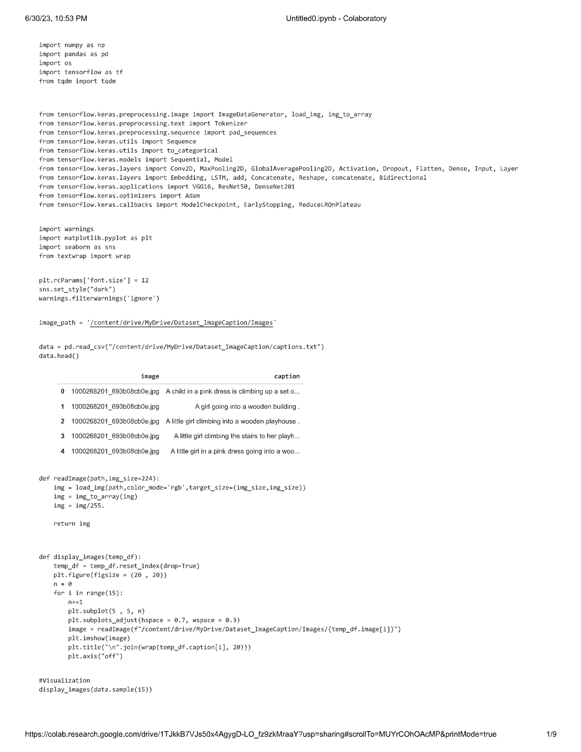

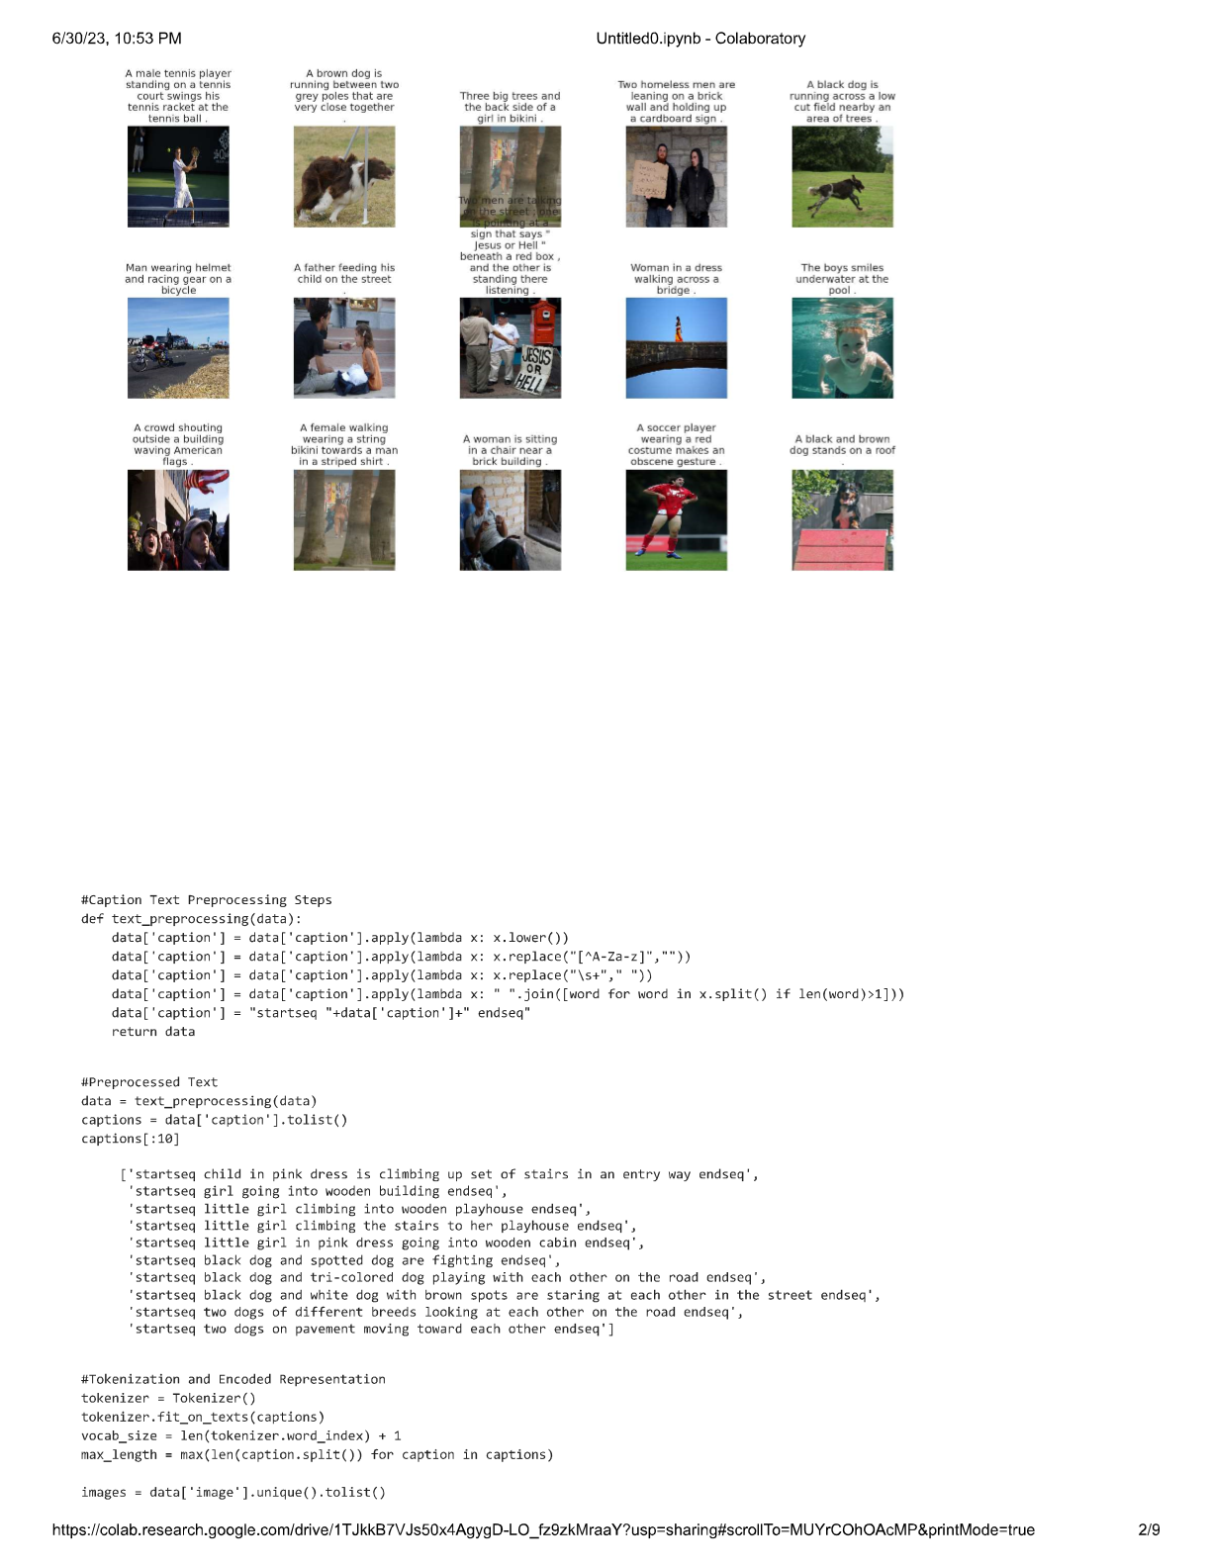

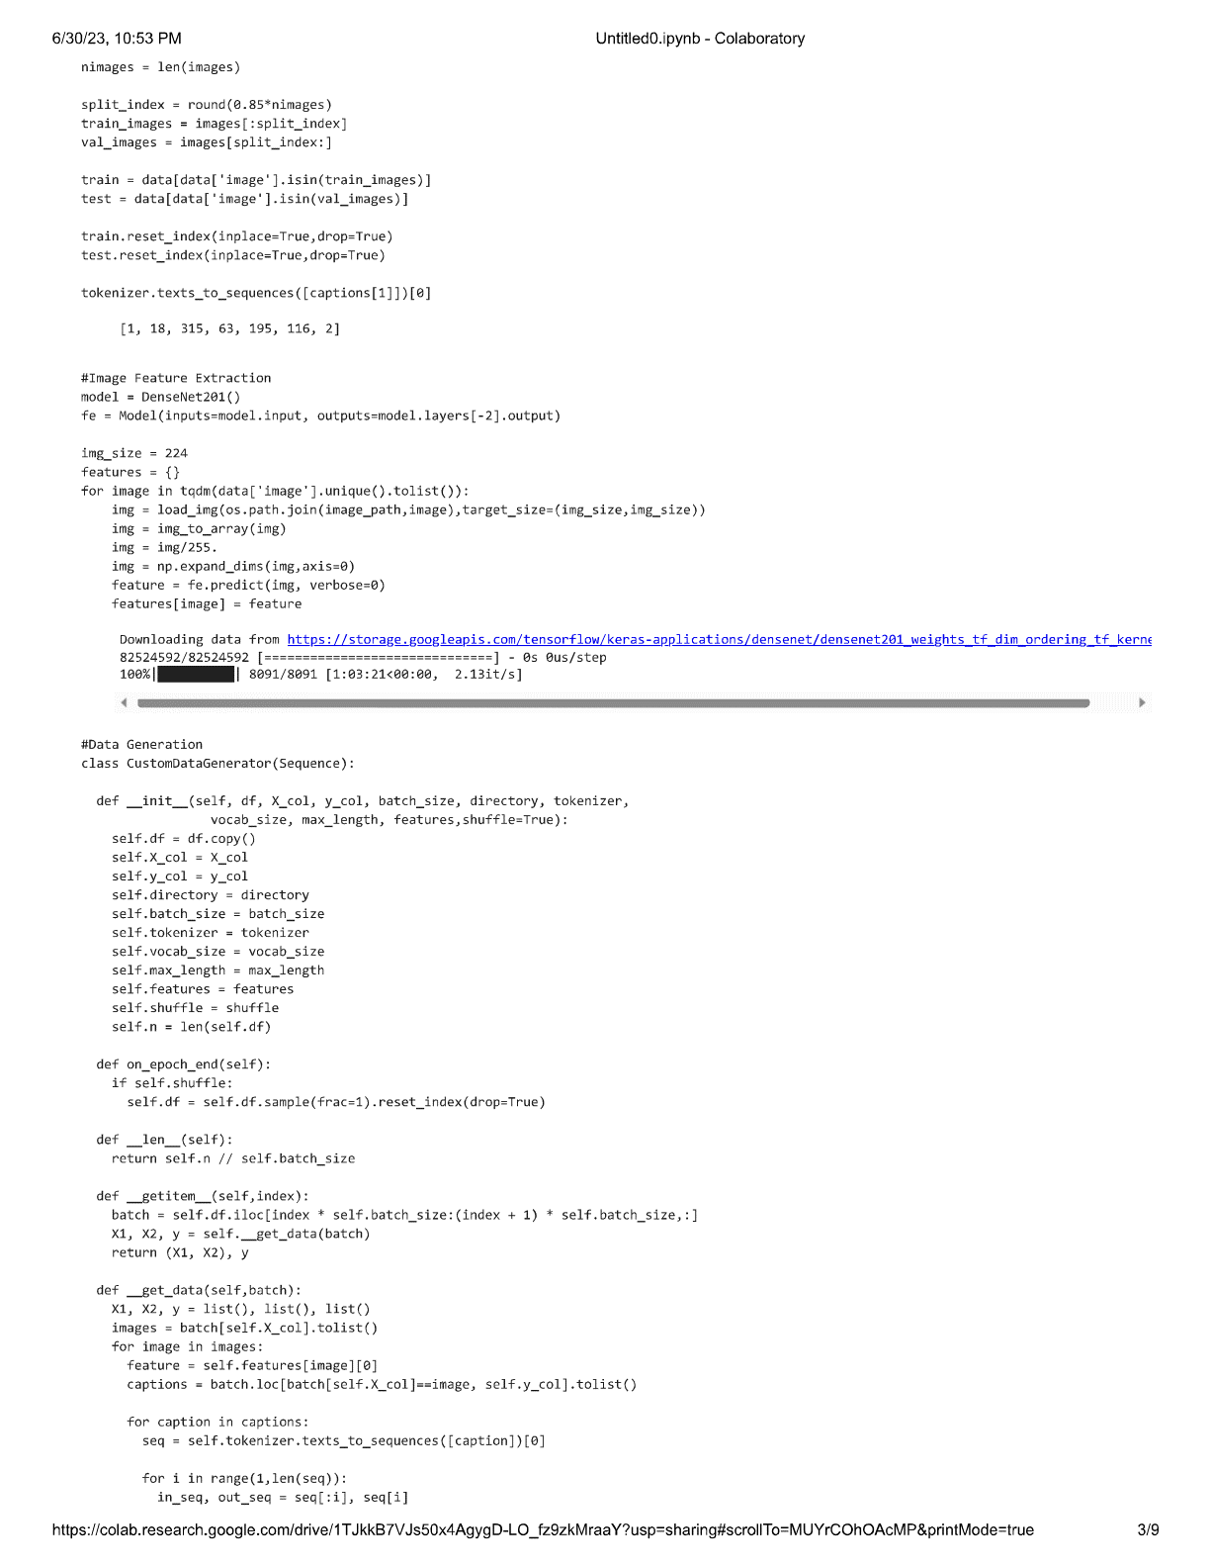

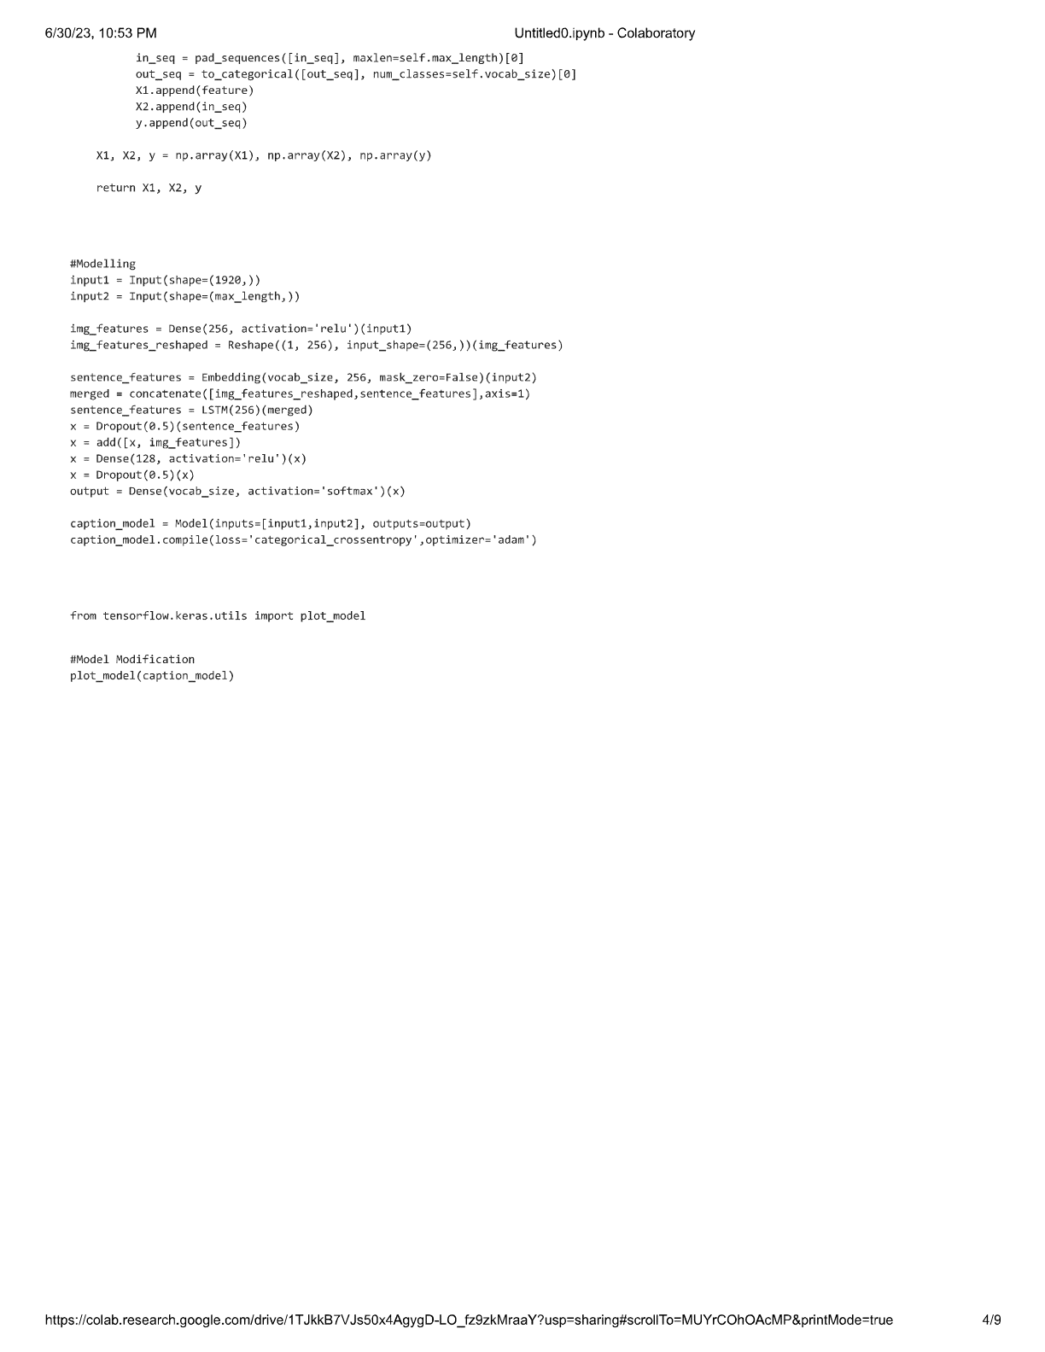

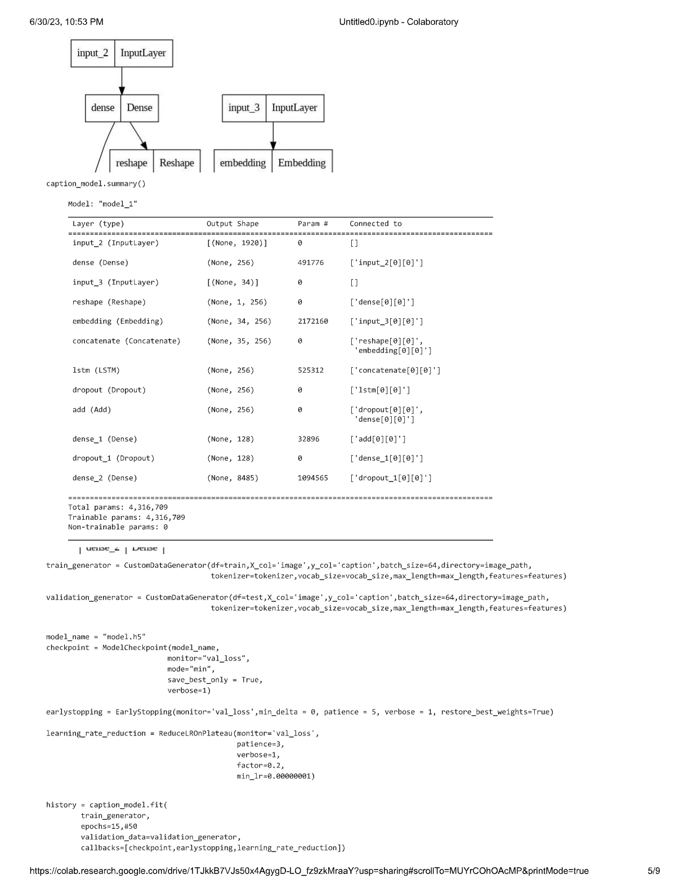

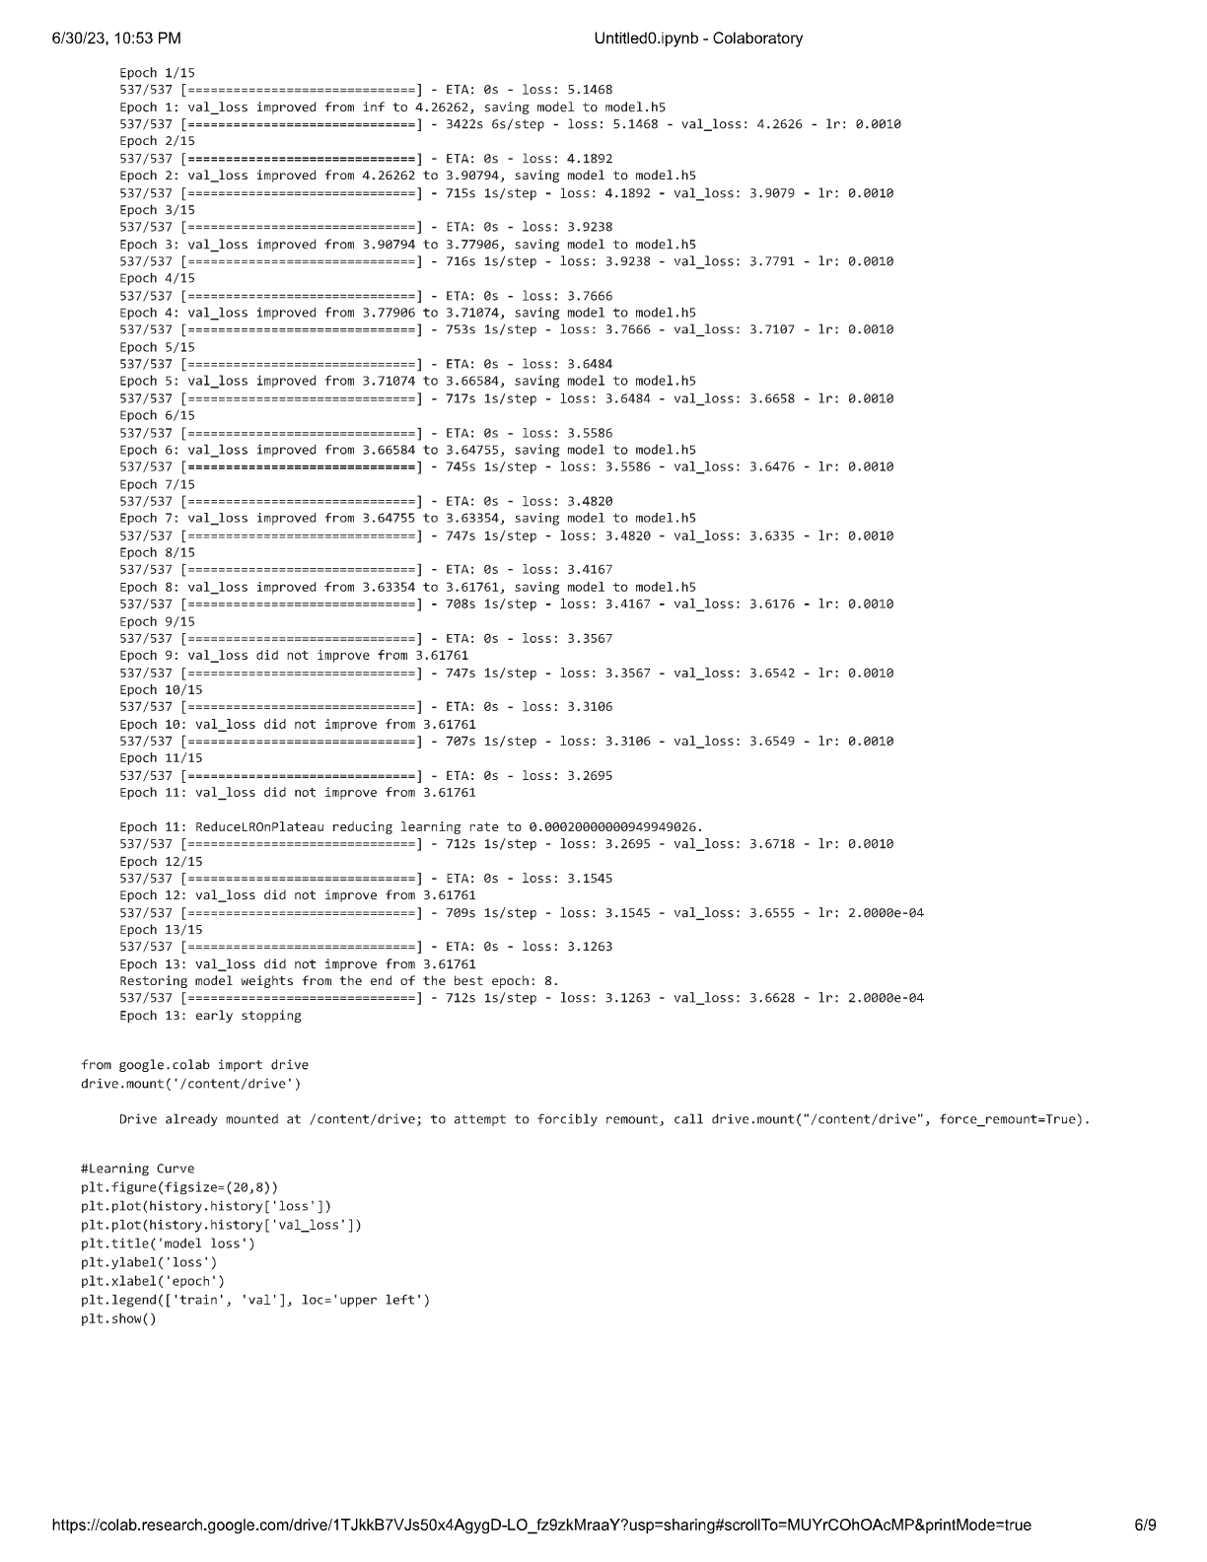

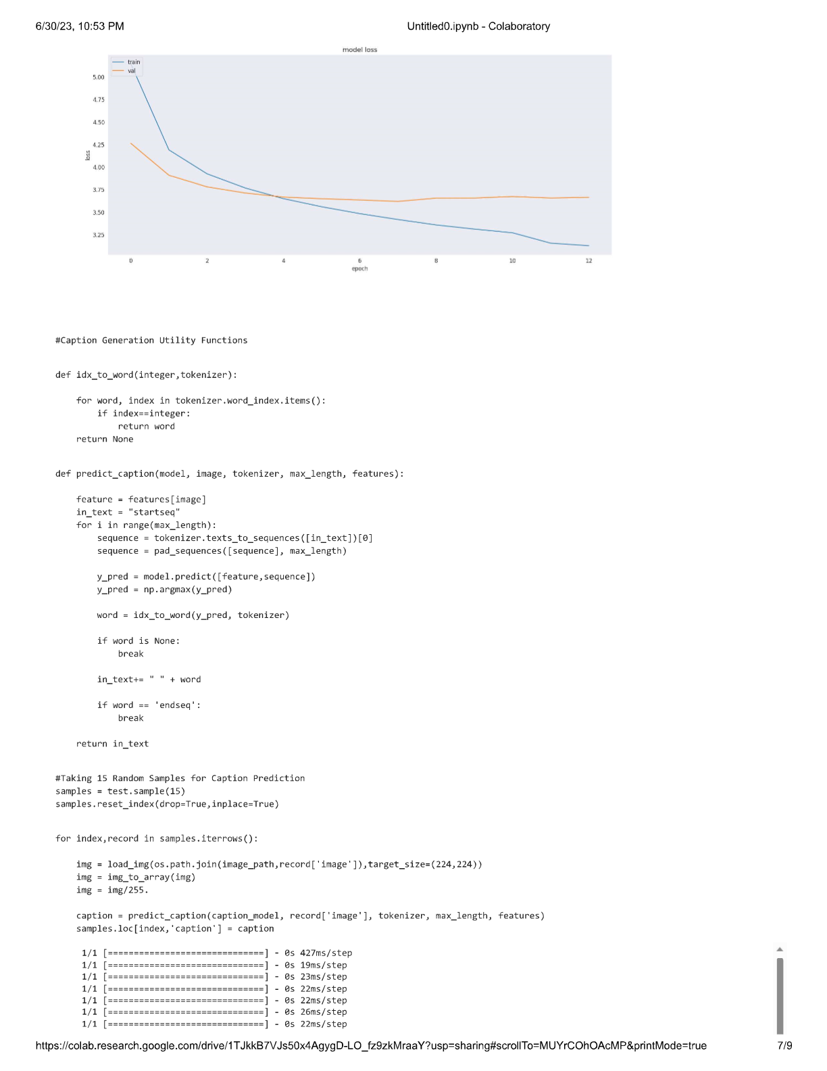

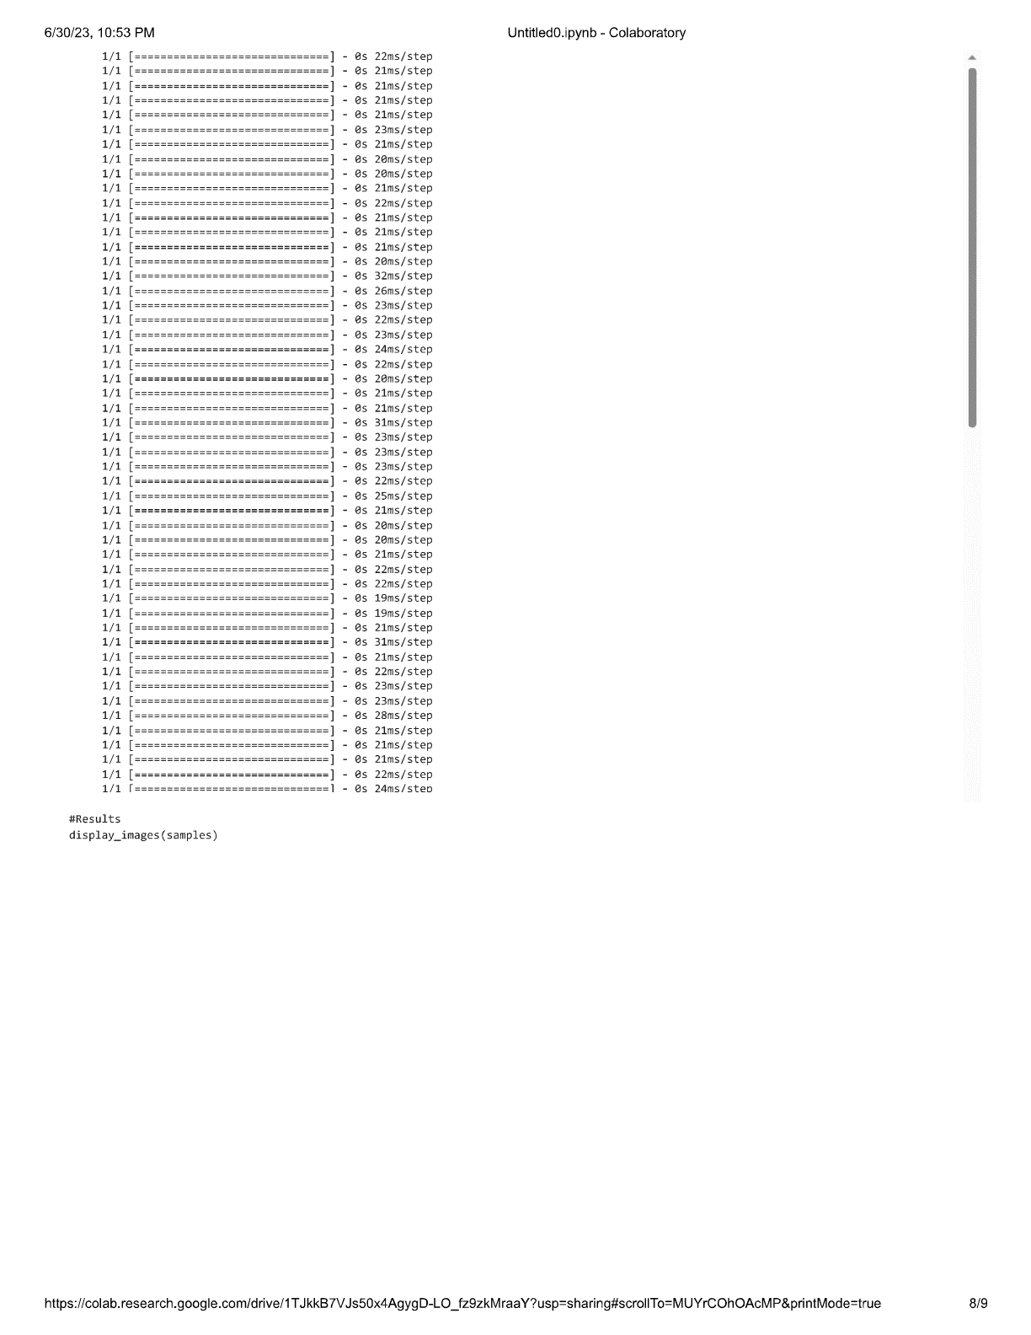

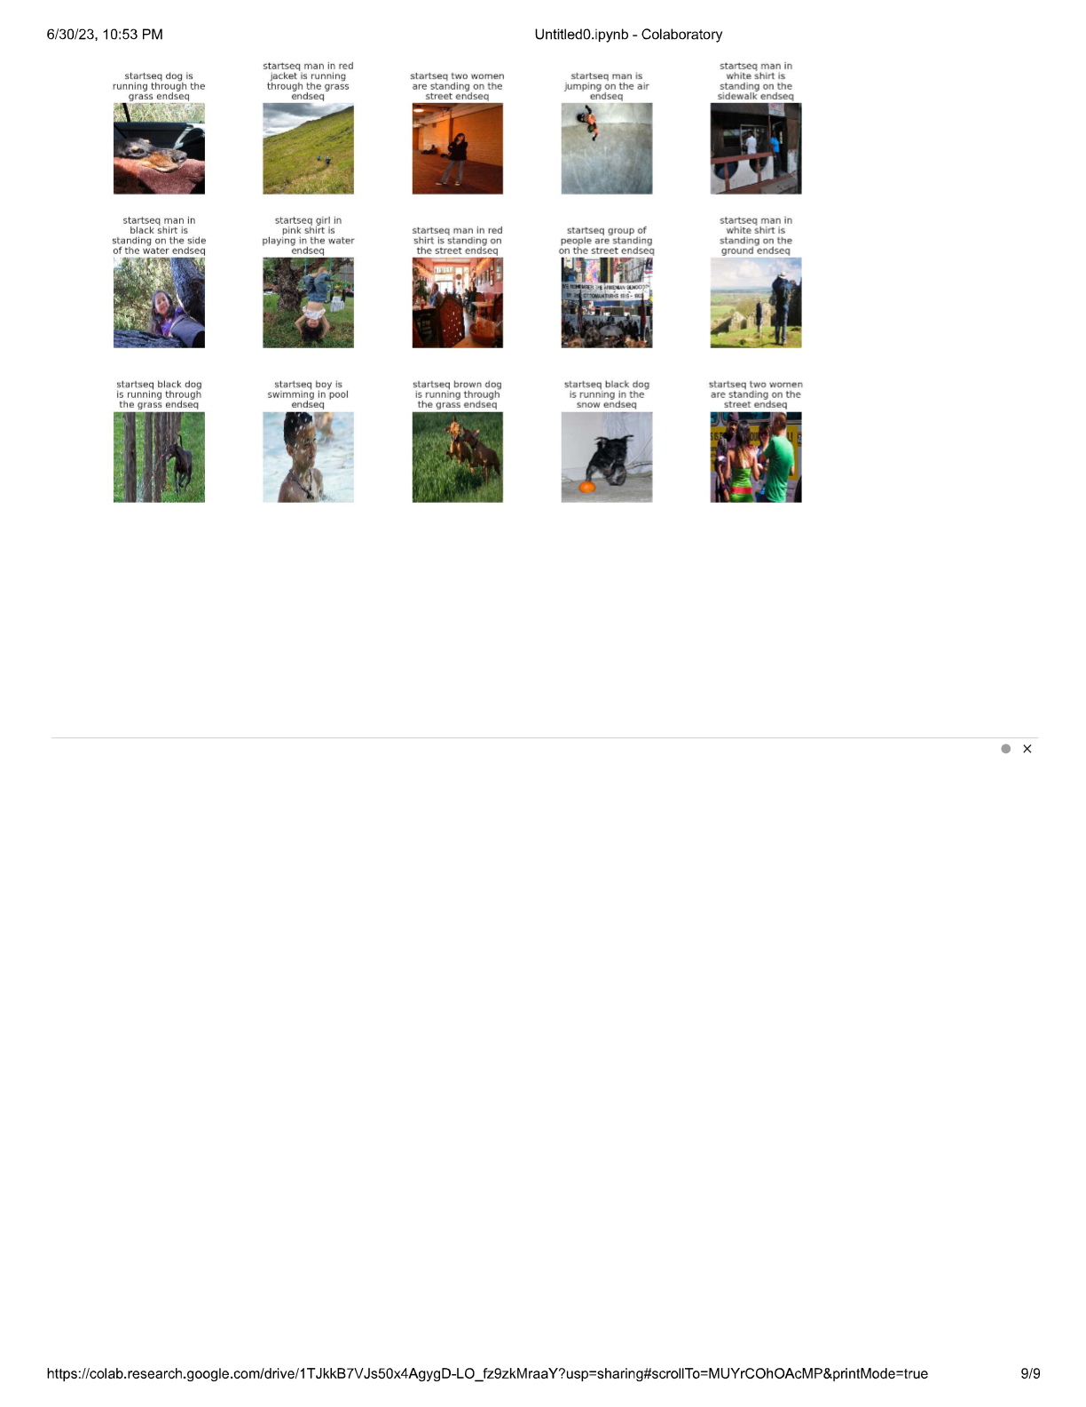

**Group no – 191**

Members:

Anubhav Shukla

Debasmita Paul

Deepshika V

Ronak Sharma

